BEB801 -- Engineering Project -- Semester One 2014

Information Retrieval Skills Worksheet

Submit to: an Assignment Minder desk
Due date: Friday 28th of March 2014 by CoB (Friday week 5)

Name: Francesco Ferraioli

Student No.: n8323143

Research Topic Title: Entity Extraction

Research Scope / Objective: Extracting faces, audio, ocr and keywords from videos

Project Supervisor: Clinton Fookes

About This Worksheet

There are seven (7) tasks set in this information skills assessment worksheet, including…

- Drawing a knowledge map / concept map of your research topic;
- Recording your most effective information search strategies. These are searches of library catalogues; journal and conference literature databases, and internet search engines;
- Identifying high-value, high-content publications on your research topic;
- Submitting a bibliography of the most relevant references.
This worksheet will be marked by your project supervisor.
On completion of this worksheet you should have formed an information retrieval strategy that will allow you to discover highly relevant published scholarly, trade and professional literature that will underpin your research project.
Advice and guidance on developing an effective information retrieval strategy is available from…
- QUT Library web site, including relevant library subject guides;
- Librarian at Library’s Learning and Research Desk (V block level 3);
- Ask a Librarian online reference service;
- Consultation with an engineering librarian (by appointment only).

- Concept Map
Draw a basic knowledge map / concept map that defines your topic

Concept maps are diagrams that show relationships among concepts. They are graphical tools that organize knowledge. Refer to Blackboard site for guidance on how to draw a concept map.

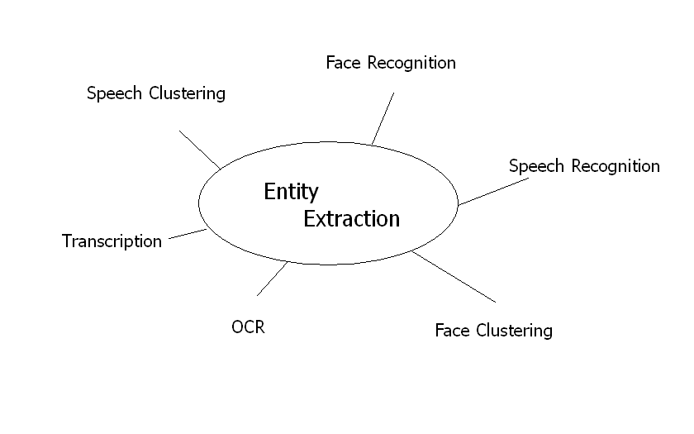

Next this worksheet requires you to take terms and phrases from your concept map to iteratively develop and refine search strategies.

Library Catalogue Searches
Search the QUT Library catalogue and the BONUS+ consortium catalogue

Keyword searches – Record several effective search keyword search statements. Ensure you show the Boolean search operators e.g., AND, OR, NOT that connect your terms. Use parentheses to group synonyms and to order precedence of search execution.

- (Speech OR Face) AND Recognition
- Video AND Transcription AND Speech
- Entity Extraction AND Speech

Subject searches - List the Library of Congress Subject headings (LCSH) assigned to the most relevant and useful catalogue records / citations. Most English language academic libraries use this same LCSH subject vocabulary. Hint… These descriptors are labelled “ Subject” in the record display of most catalogues:

- Metadata Harvesting
- MultiMedia Systems – Abstracting and indexing
- Human face Recognition
- Image Processing
- Biometric Identification

Search the BONUS+ catalogue (consortium of 13 Australian + NZ university libraries) for relevant titles. Cite the most relevant title found via BONUS+:

- Kernal learning algorithms for face recognition
- Visual speech recognition lip segmentation and mapping
- Automatic speech and speaker recognition: large margin and kernel methods
- Transcribing talk and interaction: issues in the representation of communication data

Engineering Literature Database Search
Show an efficient search strategy, from a relevant bibliographic database

List the most useful bibliographic database searched: Identify this database (and if applicable, its delivery platform). For example, Inspec (via Engineering Village); Transportation Research Information Database (TRID); ASCE Online Research Library; Compendex (via Engineering Village).

- IEEE Xplore Digital Library

For your database of choice, record the most effective search statement you used. Include your Boolean search operators e.g., AND, NEAR, ADJ, OR, NOT.

- Speech AND Recognition
- Face AND Recognition
- Video AND Transcription
- OCR AND Extraction

Note: Your database of choice may have a Thesaurus of descriptors. From the most relevant and useful search result / citation…
Record the assigned controlled vocabulary subject headings / index terms / descriptors. Note: Should there be no controlled subject descriptors in your database of choice, there may well be author supplied keywords. Indicate if this is the case:

- Speech and Audio Processing
- Speech and Signal Processing
- Automatic Face & Gesture Recognition

Briefly comment on the scope of this your chosen database and why it proved to be of high value to your literature search:

- Institute of Electrical and Electronics Engineers (IEEE) focuses mainly on papers regarding Electrical and Software Engineering.

- High-Value, High-Content Publications of Relevance
Identify rich / key information sources

Cite the most useful publication sources applicable to your research topic.
Attempt to list (at least) one of each type…

Journal / Periodical title:

- Gao, Y., & Leung, M. K. (2002). Face recognition using line edge map. Pattern Analysis and Machine Intelligence, IEEE Transactions on, 24(6), 764-779.
- Kaynak, M. N., Zhi, Q., Cheok, A. D., Sengupta, K., Jian, Z., & Chung, K. (2004). Analysis of lip geometric features for audio-visual speech recognition. Systems, Man and Cybernetics, Part A: Systems and Humans, IEEE Transactions on, 34(4), 564-570.

Conference proceeding:

- Lone, M. A., Zakariya, S. M., & Ali, R. (2011, October). Automatic Face Recognition System by Combining Four Individual Algorithms. In Computational Intelligence and Communication Networks (CICN), 2011 International Conference on (pp. 222-226). IEEE.

Handbook / Encyclopaedia / Text:

- Li, S. Z. (2011) Handbook of Face Recognition

Standards AS/NZS, ISO/IEC, ASTM, ANSI, BS, etc., standard number(s):
e.g., ASTM F2238-03 Standard test method for performance of rapid cook ovens
ISO 13372:2004 Condition monitoring and diagnostics of machines -- Vocabulary

- TSMCA.2004.826274

Patents - QUT library subject guide Patents – Searching for patents will assist.
Cite any two (2) relevant, registered Australian, European or US patents:

- Voice authentication and speec recognition system and method
- Face Recognition from video images

Patents - Identify both a US, and a Cooperative (formerly International) Patent Classification, that is relevant to your project topic:
e.g., US 219/400 Electricity -- Electric Heating -- By Convection
IPC (European) F24C 7 Stoves or ranges heated by electric energy

- G10L 13100-99/00 Speech analysis or synthesis; speech recognition

- Published Authorities
Researchers who have published on your topic

Name up to three (3) published authors who are clearly expert on your topic. You can judge this from the extent and quality of material they have published. If it is given, list their latest institutional affiliation, (i.e., where they work). Your expert may well have a professional web page that lists their more recent publications.

- M. N. Kaynak – Mictron Techology – “Analysis of lip geometric features for audio-visual speech recognition”
- S. M. Zakariya – Aligarh Muslin University – “Cobining visual features of an image at different precision value of unsupervised content based on image retrieval”
- A. K. Jain – Michigan State University – “Algorithm for clustering data”

- Internet Search
Show (at least one) efficient search strategy from an Internet search engine

Record the Internet search engine used:

- Google Scholar

Write down the most effective search statement. Include Boolean keyword, key phrase searching, and any search limiters (e.g., date, language, domain restrictors) used:

- Face AND Detection
- Speech AND Detection
- Date > 2000

Cite the three (3) most useful web sites that host relevant information on your research topic. Use the QUT APA (Author Year) style as defined in QUT cite | write to record these web sites. For each of the web sites you cite, add a short comment on the quality of the information found (e.g., reliability, accuracy, authenticity, objectivity, authority, currency, etc.):

- Castrillón-Santana, M., Déniz-Suárez, O., Antón-Canalís, L., & Lorenzo-Navarro, J. (2008). Face and facial feature detection evaluation performance evaluation of public domain haar detectors for face and facial feature detection.
- Waheed, K., Weaver, K., & Salam, F. M. (2002, August). A robust algorithm for detecting speech segments using an entropic contrast. In Circuits and Systems, 2002. MWSCAS-2002. The 2002 45th Midwest Symposium on (Vol. 3, pp. III-328). IEEE.
- Czirjek, C., O'Connor, N. E., Marlow, S., & Murphy, N. (2003). Face detection and clustering for video indexing application

- Bibliography / Reference List

Cite (using QUT cite | write’s APA style) the most relevant and useful bibliographic references you have read on your project topic. This will form the basis of your project report reference list. This list should be in alphabetical order, by first named author’s surname.

Beigi, H. (2011). Fundamentals of speaker recognition. Springer.

Castrillón-Santana, M., Déniz-Suárez, O., Antón-Canalís, L., & Lorenzo-Navarro, J. (2008). Face and facial feature detection evaluation performance evaluation of public domain haar detectors for face and facial feature detection.

Czirjek, C., O'Connor, N. E., Marlow, S., & Murphy, N. (2003). Face detection and clustering for video indexing applications.

Gao, Y., & Leung, M. K. (2002). Face recognition using line edge map. Pattern Analysis and Machine Intelligence, IEEE Transactions on, 24(6), 764-779.

Hsu, R. L., Abdel-Mottaleb, M., & Jain, A. K. (2002). Face detection in color images. Pattern Analysis and Machine Intelligence, IEEE Transactions on, 24(5), 696-706.

Jain, A. K., Murty, M. N., & Flynn, P. J. (1999). Data clustering: a review. ACM computing surveys (CSUR), 31(3), 264-323.

Jun-Bao, L. (2013) Kernel Learning Algorithms for Face Recognition

Kaynak, M. N., Zhi, Q., Cheok, A. D., Sengupta, K., & Chung, K. C. (2001). Audio-visual modeling for bimodal speech recognition. In Systems, Man, and Cybernetics, 2001 IEEE International Conference on (Vol. 1, pp. 181-186). IEEE.

Kaynak, M. N., Zhi, Q., Cheok, A. D., Sengupta, K., Jian, Z., & Chung, K. (2004). Analysis of lip geometric features for audio-visual speech recognition. Systems, Man and Cybernetics, Part A: Systems and Humans, IEEE Transactions on, 34(4), 564-570.

Lone, M. A., Zakariya, S. M., & Ali, R. (2011, October). Automatic Face Recognition System by Combining Four Individual Algorithms. In Computational Intelligence and Communication Networks (CICN), 2011 International Conference on (pp. 222-226). IEEE.

Waheed, K., Weaver, K., & Salam, F. M. (2002, August). A robust algorithm for detecting speech segments using an entropic contrast. In Circuits and Systems, 2002. MWSCAS-2002. The 2002 45th Midwest Symposium on (Vol. 3, pp. III-328). IEEE.

--+| End of Worksheet |+--

